**AE 771 Combustion Design Project**

**Due: Wednesday April 1st, 2020**

**Henry Hunt**

**Project Objectives**

1. Designing a combustion chamber to connect to the conical and Rao nozzles.

2. Determining the frequencies of the first longitudinal, radial, and tangential modes for the combustor.

3. CAD model of the complete combustor-nozzle assemblies

4. Table of assumed and calculated values.

**Code and Workflow**

<https://github.com/Drifterino/AE-771/blob/master/Design%20Project.ipynb>

**Assumed and Given Values**

|  |  |  |  |
| --- | --- | --- | --- |
| **Symbol** | **Value** | **Variable** | **Units** |
| F | 10000 | Thrust | Lbf |
| P1 | 1000 | Chamber Pressure | Psia |
| MR | 3.4 | Mixture Ratio | Unitless |
| 𝔐 | 8.90 | Molecular mass | lbm/lb-mol |
| T1 | 4380+459.67 | Combustion Temperature | Rankine |
| K | 1.26 | Ratio of Specific Heats | unitless |
| P3 | 1.58 | Ambient Pressure | psia |
| P2 | P3 | Optimum Operation Pressure | Psia |
| VCF | 0.97 | Velocity correction factor | unitless |
| TCF | 0.98 | Thrust correction factor | unitless |
| Go | 32.2 | Acceleration due to gravity | ft/s^2 |
| Tp | 152 | Time of propulsion | Seconds |
| R | 1544 | Specific Gas Constant | ft⋅lbf⋅slug−1⋅°R−1 |
| ρo | 71.1 | Liquid Weight Density of Oxygen (Oxidizer) | lbf/ft^3 |
| ρf | 4.4 | Liquid Weight Density of Hydrogen (Fuel) | lbf/ft^3 |
| SG | 0.26 | Specific Gravity | unitless |

**Combustion Chamber Values**

|  |  |  |  |
| --- | --- | --- | --- |
| **Symbol** | **Value** | **Variable** | **Units** |
| CCL | 10 | Combustion Chamber Length | inches |
| CDA | 45 | Convergence Duct Angle | degrees |
| CDL | 2.2 | Convergence Duct Length | inches |
| CDD | 5.4 | Combustion Duct Diameter | inches |

**Calculated Nozzle Values**

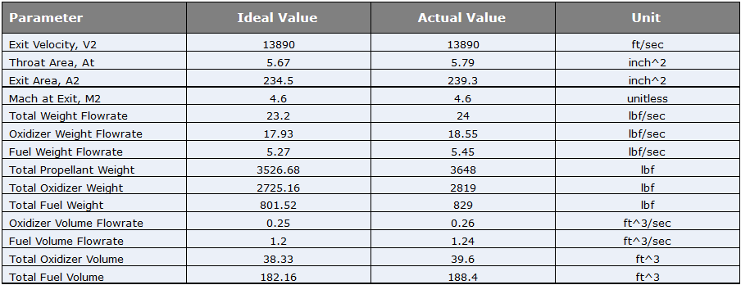

**Resonance Frequencies**

|  |  |  |  |
| --- | --- | --- | --- |
| **Symbol** | **Value** | **Variable** | **Unit** |
| RFlong | 617.125 | 1st Longitudinal Mode | Hz |
| RFrad | 1147.976 | 1st Radial Mode | Hz |
| RFtan | 365.412 | 1st Tangential Mode | Hz |

**CAD Models | Available on the GitHub as ConeHW8.prt and RaoHW8.prt**

